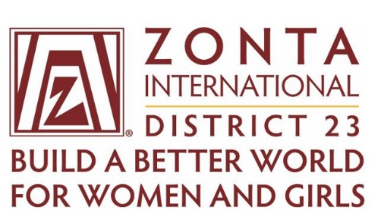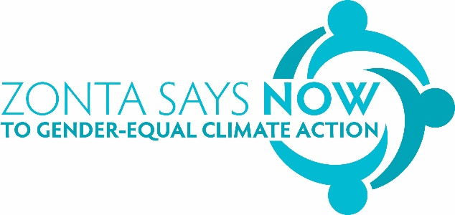

District 23 Zonta International Women Taking Climate Action Award

The Women Taking Climate Action award recognises women whose climate actions significantly contributes towards mitigating the negative aspects of climate change and their climate action engages with women.

Applications are open to residents of Zonta International District 23 – residents of W.A., S.A., Vic., Tas., and N.T.

History of the Women Taking Climate Action Award

Zonta Club of Melbourne on Yarra http://zontamelbourneonyarra.org.au/wp1/
in conjunction with Zonta Says Now https://zontasaysnow.org.au/ piloted the Women Taking Climate Action Award for 2021.

$1000 was raised for the Award from ticket sales for a Climate Action webinar in 2020 with Natalie Isaacs, founder of One Million Women.
https://www.1millionwomen.com.au/
One Million Women advocates that small actions and changes can create big benefits for the environment. Natalie Isaacs was a guest speaker at the 2023 District 23 conference in Bunbury W.A.

The award winner for 2021 was Margaret Hender

. In 2013 Margaret created CORENA
(Citizens Own Renewable Energy Network Australia). https://corenafund.org.au/

CORENA is Australia’s first solar revolving fund. CORENA lends money to small non-profit organisations to install solar, invest in energy efficiency, getting off gas or purchasing electric vehicles. CORENA collects donations and then loans money to non-profits who repay without interest. The repayments are used to fund further projects. By 2021 CORENA had successfully funded 44 projects and their funds for lending are growing. To 2021 the $800,000 CORENA has been able to loan has generated almost $200,000 in savings for the non-profits. CORENA offers an opportunity to reduce bills in a manner that requires no capital outlay and allows all savings to flow to the organisation once the loan is repaid.
CORENA’s key positions are all held by women. This is significant in the energy sector which is still very male dominated. As well, there are many women involved in not-for-profit organisations and they can feel daunted by having to make investment decisions related to energy. CORENA offers independent technical advice and support.
CORENA loans are repaid, and on time. This is a model with potential sustainable growth and now CORENA is starting to attract larger philanthropic donations.

The award winner for 2022 was Emma Cutting

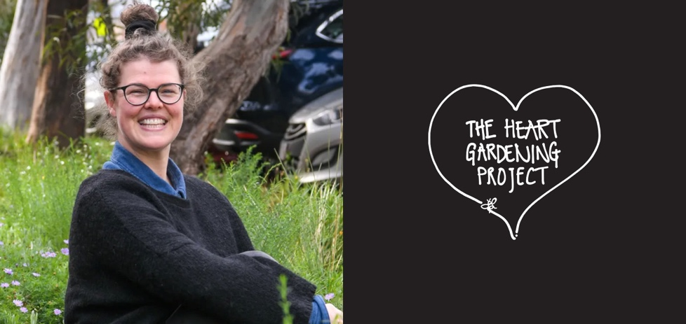
https://theheartgardeningproject.org.au/

For The Heart Gardening Project Emma brought together community and scientists to create not only local gardens but also to begin a corridor of plantings, the Melbourne Pollinator Corridor, that would enable the retention of pollinating plants, insects, birds, and wildlife. She also managed to combine the environmental planting and maintenance activities with mental health support for the community. Most members and workers are women and they have been able to be initiate environmental action, gain advocacy skills and be a close support group. A project which will take several years to come to fruition but will have an enormous impact on the future health of the environment and community.

For 2023 there were two award winners due to a one-off donation The co-winners – Dr/Professor Anne Poelina, a Nyikina Warra woman from the Kimberley region of WA, and Alana Mountain from Victoria.
Two outstanding women who share a strong connection to ‘caring for country’ – the essence of and reason for caring about climate action.
Alana’s statement in her application about her ethos of action was:
‘I acknowledge First Nations Justice, gender equality and environmentalism as the basis of my work. I believe in connecting people back to the land to protect and conserve it for future generations. I strive for a healthier planet for all inhabitants.’
This is where we want to be as a nation – a respect for western and indigenous knowledge, a working partnership.
Also, in common is the fact that both women are excellent role models, emphasise advocacy, community education and add a high level of scientific and academic understanding to their work.

Alana Mountain, from Victoria, is the Campaign Coordinator of the Forest Collective.

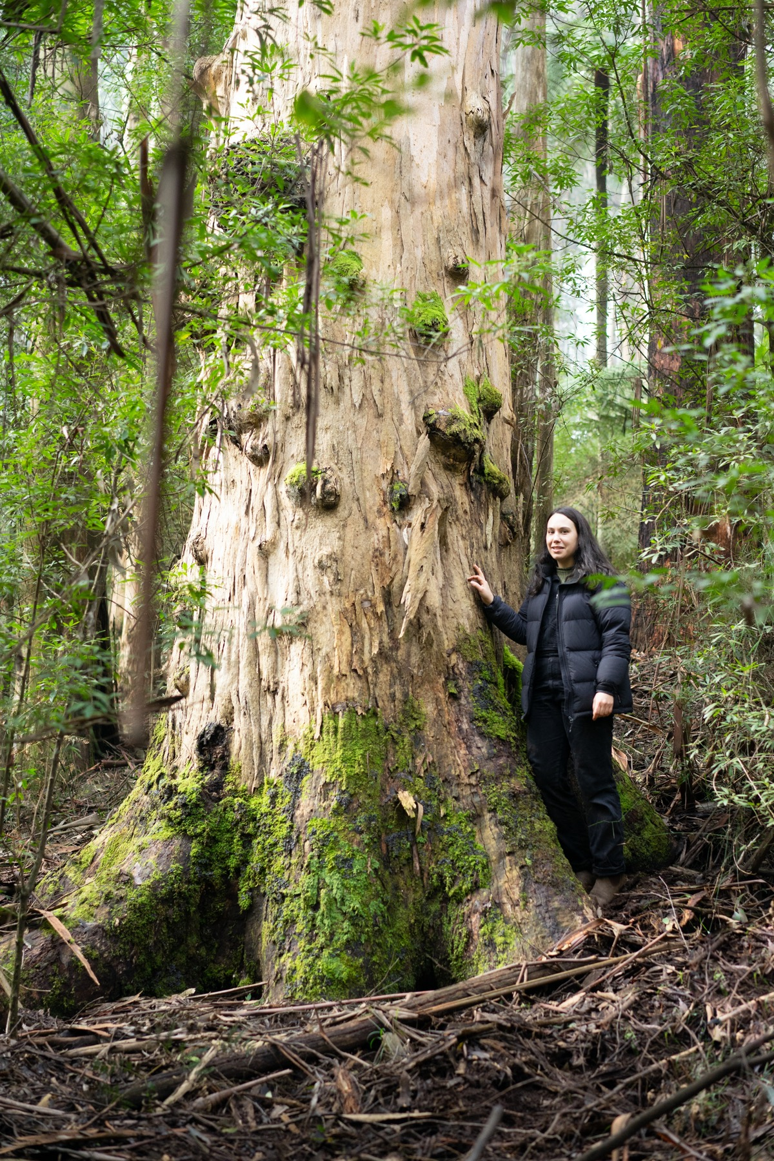

With Alan’s award we celebrated and acknowledged 10 years of determination and dedication to protect the beautiful flora and fauna of the Central Highlands of Victoria. Her efforts have helped culminate in the decision by the Victorian government to end the logging of native forests, a decision that will help protect the densest carbon-rich plant on earth – Mountain Ash, the forest that we need to survive and the endangered Greater Glider.
Alana has encouraged women to become tree climbers, an activity that was largely considered male. This supported the collection of data to show the effects of logging on native wildlife – particularly the endangered Greater Glider. This research was used in a legal case to show successfully that the logging industry had not been taking the necessary studies and steps to protect the Greater Glider. This legal decision managed to ultimately shut down the logging of native forests in Victoria due to the legal, economic, and political ramifications of the decision.

Dr/Professor Anne Poelina is a Nyikina Warrwa woman from the Kimberley Region of Western Australia.

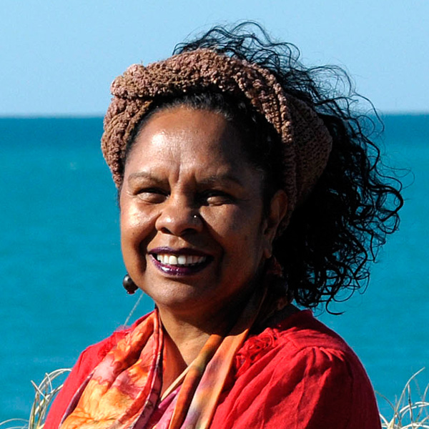
She is a community leader, human and Earth rights advocate. She is linked to the land and water of the Kimberley Region and has for many years helped heal country, climate, and communities in this region.
Anne is currently a Professor and Research Fellow at Notre Dame University WA, Charles Darwin University NT, and ANU. She is Chair of the Martuwarra Fitzroy Council and a member and director of the Kimberley Land Council and is involved with the Murray Darling Basin as its inaugural indigenous member on the Advisory Committee on Social, Economic and Environmental Sciences.
Anne is recognised globally for her work with climate and water justice and with First Nations women – giving them opportunities to have a voice and leadership opportunities. She sees her role as protecting ‘Mother Earth’ and the importance of indigenous knowledge in being able to do this. She says that traditional women’s law is about maintaining and protecting the spirit of the country, and that is central to protecting humanity now. Anne promotes two-way science, which connects Western and indigenous knowledge.
She works nationally and internationally as a water management advisor and is very concerned with protecting the Fitzroy River in the Kimberley area. She has also just been appointed to the Australian Productivity Commission to work in water management.

2024 Award Winner – Jane Baker, Mrs Baker’s Still House

The award promotes Zonta’s commitment to environmental issues, and Jane Baker of Mrs Baker’s Still House in Elmhurst, Victoria, exemplifies this mission by the Zonta Club of Central Goldfields, by Jane runs an all-female distillery that produces gins, liqueurs, and whiskies using sustainable, low-impact methods. Her business sources botanicals locally, operates on 100% solar power, and reflects the alignment between sustainability and economic viability.
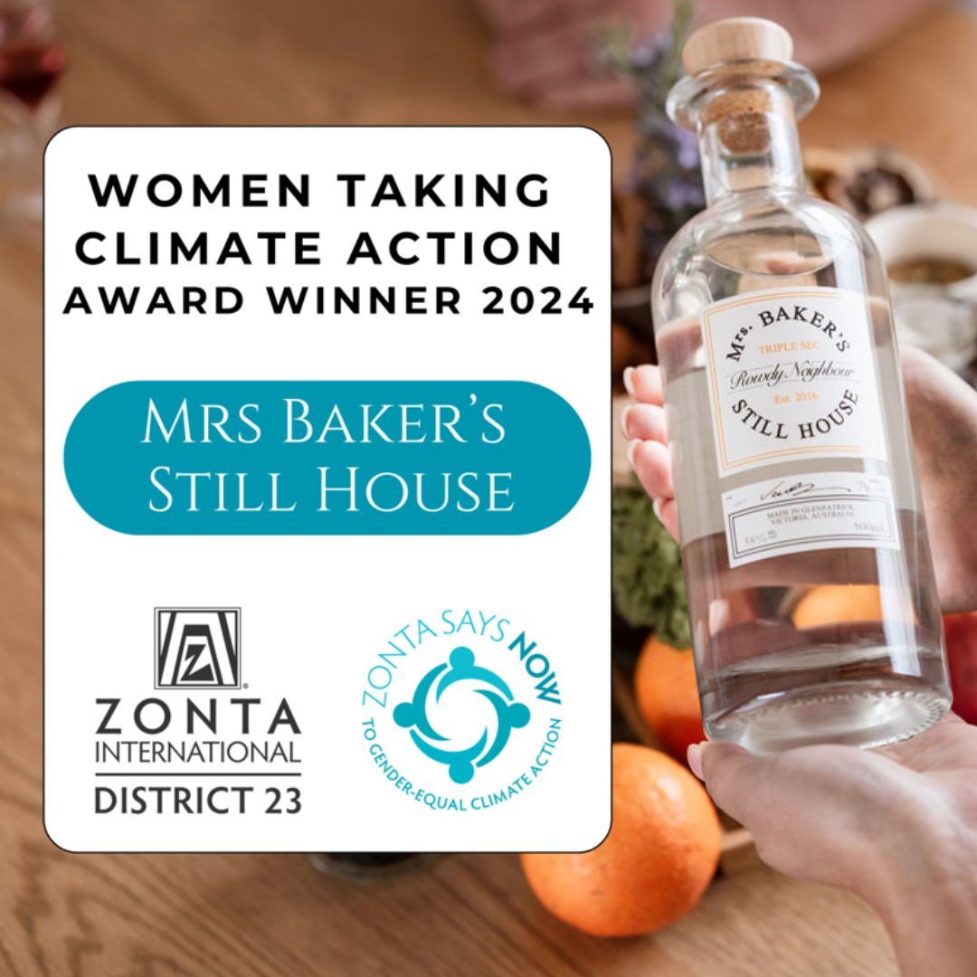

2025 Award winner – Sally Quinn, Green Collect

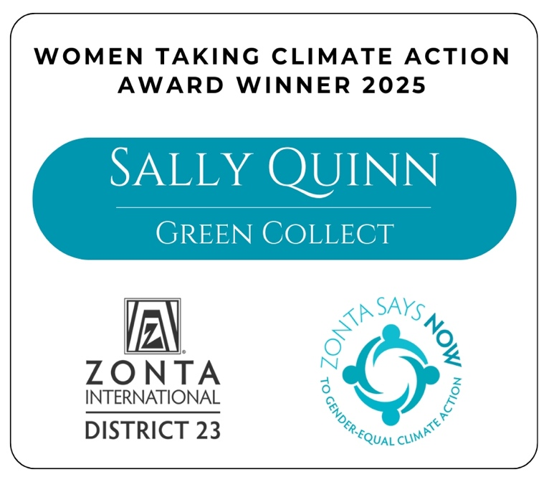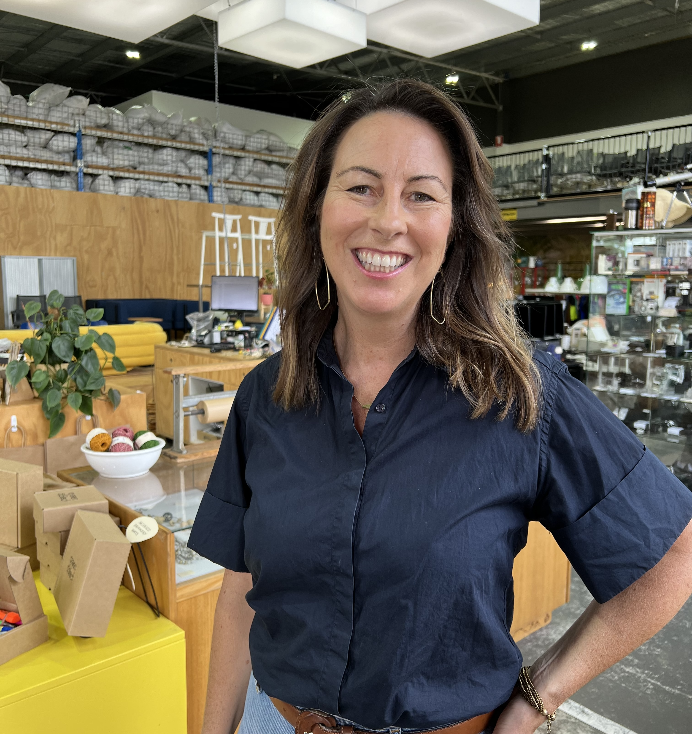

The 2025 Women Taking Climate Action Award goes to Sally Quinn, Co-Founder and CEO of Green Collect, a social enterprise in Braybrook, Victoria. Green Collect transforms commercial office and e-waste through reuse, recycling, and repurposing, saving around 1,000 tonnes of CO₂ annually while promoting social inclusion.
The organisation provides employment pathways for refugees, youth, and women, with an 80% female leadership team and over 50% female staff—remarkable in an industry with less than 20% female representation. Green Collect also runs circular economy workshops, shares data and helps businesses take meaningful climate action. Innovative, impactful, and gender-equitable, Green Collect exemplifies Zonta’s vision of climate action.

